Problem Statement 1:

Ingest data from a single table in SQL Serevr database to Azure Blob storage.

I solved this problem by using my ADF user -interface to create a data factory pipeline that copies data from a SQL Server database to Azure Blob storage.

* I created my data factory, ADFProjectDataFactory
* I created a storage account, azureblobstoragechika as a destination or sink data store.
* I created a self-hosted integration runtime (which I did a couple of times) and associated it with an on-premises machine with the SQL Server database so as to copy data from the SQL Server database on my machine to blob storage.
* I created SQL Server and Azure Blob storage linked services.
* I created SQL Server and Azure Blob datasets.
* I created a pipeline with the copy activity to move the data.
* I debugged, validated and published my work
* Finally, I triggered the pipeline run and monitored the pipeline run to make sure it succeeded.

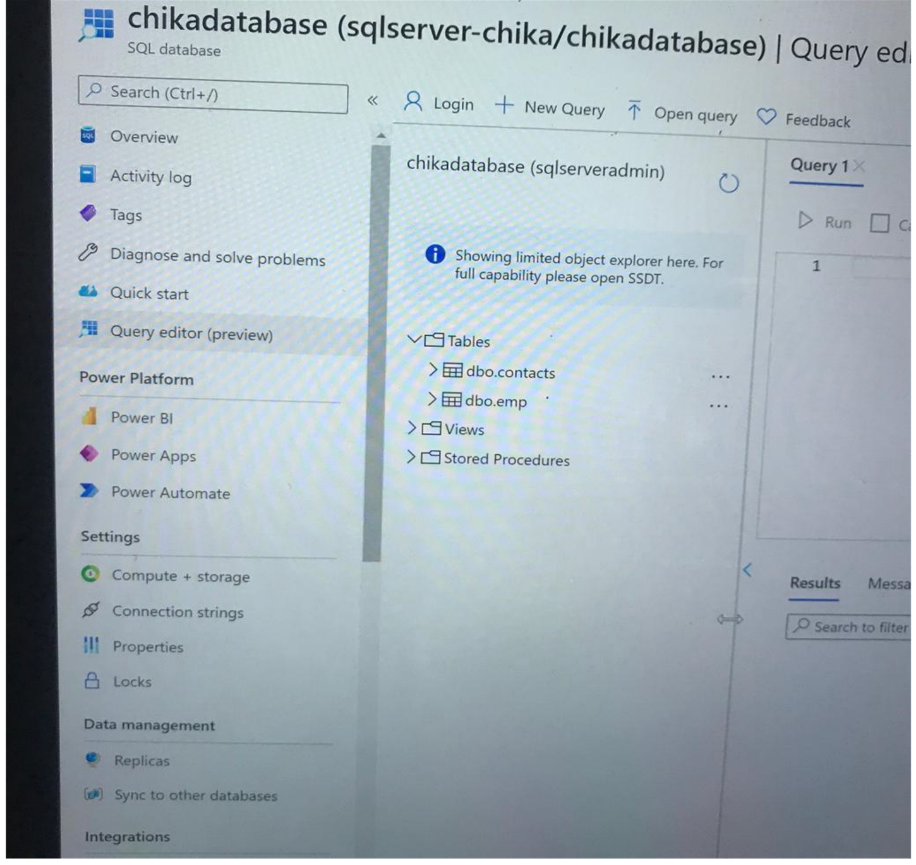

Figure 1: tables with my datasets

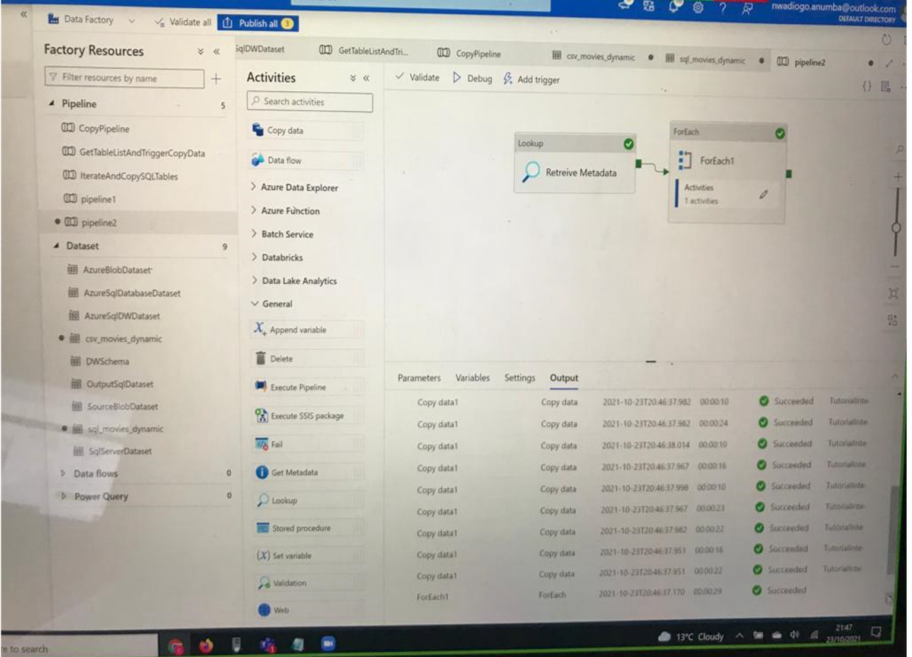

Figure 2: My succeeded pipeline runs